**SSD Diagram**

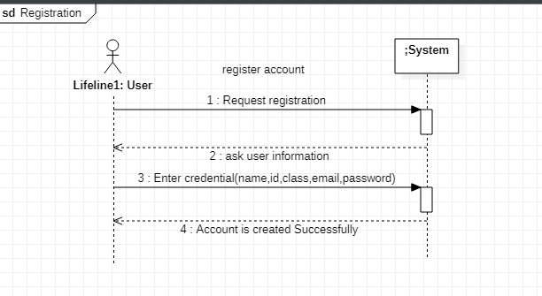

**Contract Operation**

#### Use Case UC1: register account

**Contract ID**: Request Registration

**Operation:** Request Registration ()

**Cross References:** Use cases: Register account

**Pre-conditions:**

* User is not registered.
* The System is running correctly.­­

**Post-conditions:­­**

* User is registered and Account is created successfully.

**Contract ID**: Enter Credential

**Operation:** Enter information ()

**Cross References:** Use cases: Register account

**Pre-conditions:**

* User is not registered.
* The System is running correctly.
* All enter information should be in proper valid form.

**Post-conditions:**

* User is registered and Account is created successfully.

**Package Diagra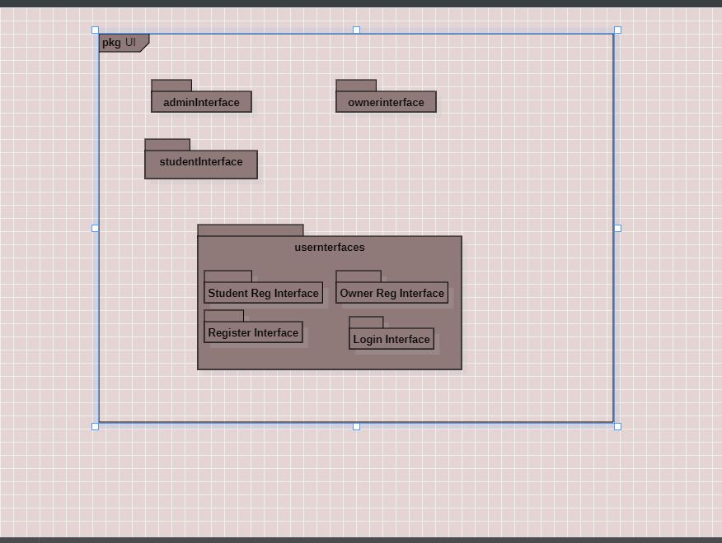m**